Both in the year 2017 and 2018 we have been in Thailand for several weeks, to visit the refugees of the Karen tribe in Pala – U and Padeng together with Bob. We also brought the money we collected for the project of Bob (during birthdays) and the profit of the charity pot of the elders in law of our son. Some members of our local church donated gifts. To all supporters: Thank you very much, also on behalf of Bob!!!!!

In November of 2016 and 2017 I gave a little presentation in our local church. Afterwards a collection took place and both times the yield was about € 600,00. This is used by our diaconie for the monlty supporting. Bob uses it for the food project, for diapers for disabeled childs and for medicines for one of them. Nowadays Bob already provides 27 families with food. It’s nice to be with him to deliver the goods at the Bible school and to visit the families.

Shopping on the market and delivery at the Bilble school.

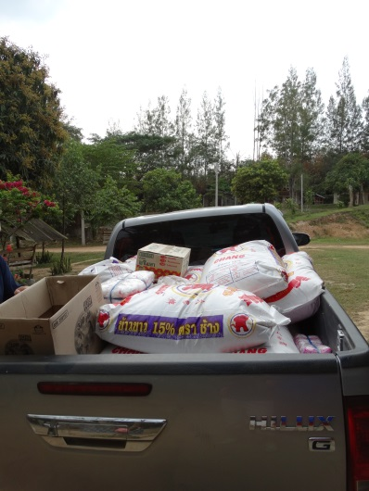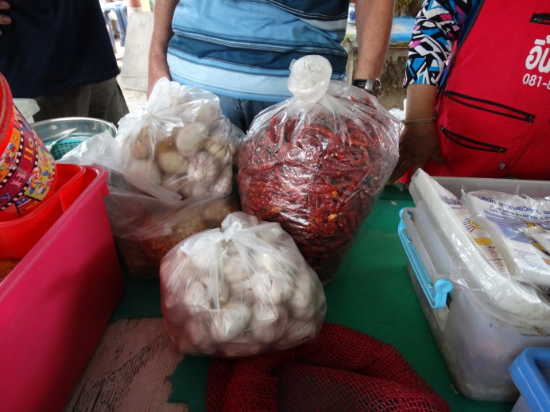

We visisted two families. The recognized us from previous years. However we could not understand each other. A grandmother with her heavily physically and mentally handicapped granddaughter and a family with a blind handicapped father who misses an arm and fingers on his good hand. They too had a severely disabled daughter. She died in October 2017. They now have a son and a daughter. The goat farm that is runned by these people now seems to be going well because of the help of Bob's work. It would be nice if this project can now be closed and they can save themselves in the future.

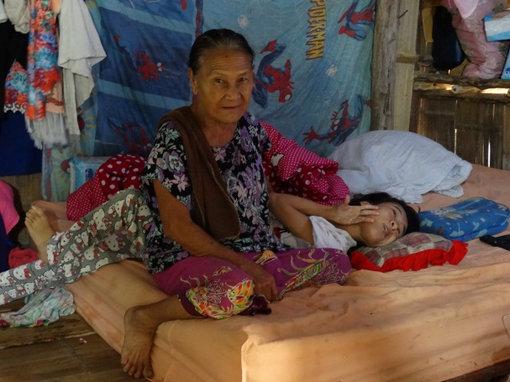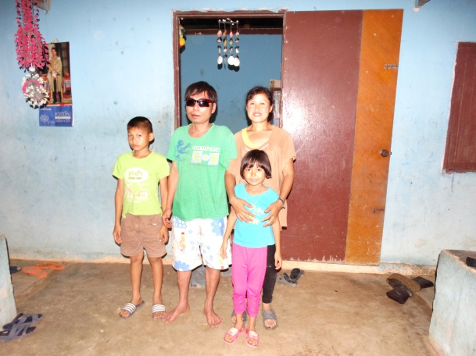

Then we went to the children's home in Padeng where we also brought a supply of rice, shrimp paste and oil. From the money we had taken with us, we also bought extra things on the market such as peppers, garlic and sweets for the children. When we delivered the stuff, a number of children had to transport the heavy bales of 49 kg from the car to their storage shed:
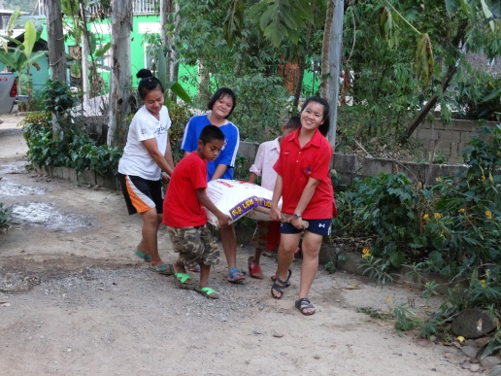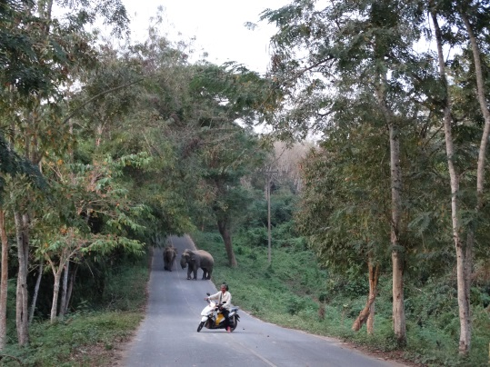

On the way we had some delays because two elephants were on the road. They were angry at each other and it was probably not safe. Just as the man on the engine we turned the car.. A moment later Bob put the siren on his car and then they went into the forest.

In 2017 we visited also a village where people had lost everything because of a flooding in the south around Christmas 2016. We also brought rice there in Bang Saphan (200 km south of Hua Hin).

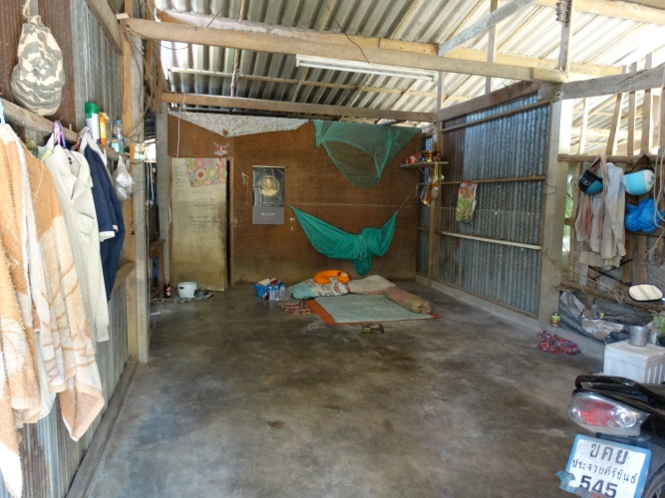

And at a school where the children had lost their uniforms because of the flood, a new one was brought in for all 70 students with money from Asia Care Foundation.

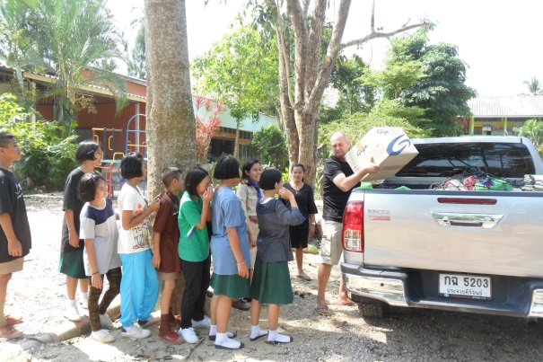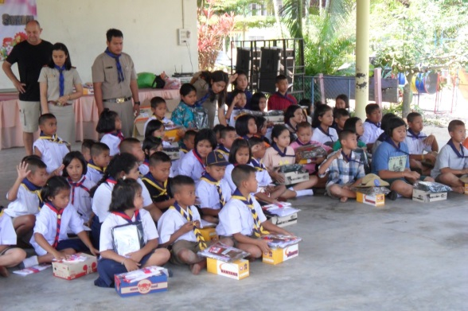
After our holiday and the visit to the project I gave a presentation for a women's association of the church. In this way, Jan and I hope to bring Bob's work to the attention and to attract donors.

Jan and Janny

